**Iraqi J. Aquacult. Vol. (00) No. (0) 2025: 00-00 00**

**ــــــــــــــــــــــــــــــــــــــــــــــــــــــــــــــــــــــــــــــــــــــــــــــــــــــــــــــــــــــــــــــــــــــــــــــــــــــــــــــــــــــــــــــــــــــــــــــــــــــــــــــــــــــــــــــــــــــــــــ**

**Title: Should be brief, specific, and related to the topic.**

**(Georgia - 14 font -bold)**

**The total name for Author or Participating Authors/ According to below: Full First name the first letter of the father's name then a Surname**

**Example:(Ahmed K. Sultan) Insert ORCID** **iD** **for Authors.**

**(Georgia - 12 font -bold)**

Author/ Authors Addresses, according to: Scientific Department, College, University, City, Country.

Put numbers (1, 2, 3) after the of authors names if the Authors belongs to different affiliates

1 First Affiliation.

2 Second Affiliation. etc…

(Georgia - 11 font)

*Corresponding Author E-mail: [mhaisenft@yahoo.co.uk](mailto:mhaisenft@yahoo.co.uk)

(Georgia - 11 font)

**ــــــــــــــــــــــــــــــــــــــــــــــــــــــــــــــــــــــــــــــــــــــــــــــــــــــــــــــــــــــــــــــــــــــــــــــــــــــــــــــــــــــــــــــــــــــــــــــــــــــــــــــــــــــــــــــــــــــــــــ**

|  |
| --- |
| Received 00/00/2025 Accepted 00/00/2025 Published 00/00/2025 |
| **Abstract** |
| A brief and factual summary is required. The abstract should briefly state the purpose of the research, the main results, and the main conclusions. The abstract is often presented separately from the research or article, so it must be comprehensive with all the contents of the research. For this reason, you should avoid citing sources. Also, nonstandard, or uncommon abbreviations should be avoided. The abstract should not exceed 250 words.  (Georgia - 11 font)  **Keywords**: They are 3-5, expressive of the content. (Georgia - 11 font) |

**Notes**

* • Page margin size is 2.5 cm on all sides.
* • The distance between lines spacing is 1.15.
* • The distance between the beginning of the paragraphs is 0.5 cm.

**Introduction** (Georgia - 12 font)

State work goals and provide appropriate background, avoiding a detailed survey of literatures or a summary of results.

The reference to the sources is as follows:

1. If the reference consists of one author:

Write the surname of the author (without the initials) and the year of publication, for example: “As indicated by Ahmed (2000) or (Ahmed, 2000), and so on, according to the source citation, whether it is within the context of the speech or outside its context, as in the second citation of the author Ahmed.

2. If there are two references for one author in the same year:

Write the surname of the author (without the initials) and the year of

publication, for example: “As explained by Ahmed (2000a, b) or

(Ahmed, 2000a, b) and so on, according to the reference citation, whether it is within the context of the speech or outside its context.

3. If the reference consists of two authors:

The surnames of both authors and the year of publication should be included, for example:

As shown by Thomas and Brain (1986) or (Thomas and Brain, 1986) if the citation of the reference is not within the context of speech. Do not replace the word 'and’ with the '&' symbol.

4. If the reference consists of three or more authors:

Write the surname of the first author followed by '*et al*. (italics) and the year of publication, for example:

Frank *et al*. (2010) or (Frank *et al*., 2010) if the source was cited out of context.

Reference groups of the same sentence should be listed in chronological order.

**Materials And Methods**

Provide detailed information about the work methods, including a description of the study sites, the equipment and supplies used, laboratory experiments and field work, and the sources approved in the work methods.

**Results**

The results should be clear and concise, and several sub-headings may be included under the results section. It must provide an accurate and detailed description of the results of the experiment or study.

The results include figures, tables, pictures, charts, etc. Figures, tables and charts, all of which are serially numbered according to their occurrence in the text, and all figures and tables must be mentioned in the main text, such as Fig. 1, Table 1, and so on.

Use the word (figure) in full as a title under the figure or what it represents, and when referring to it in the text, it uses (Fig.)

Titles of figures, tables, and images must express the content and be written in Georgia font, size 11.

for example:

Figure 1: The effect of temperature on the growth rates of common carp larvae.

Table 1: Nutrient ratios recorded in grass carp ponds in Essaouira.

Figures, Tables, Pictures and diagrams

* The table layout should be as follows:

|  |  |  |
| --- | --- | --- |
| **Title 1** | **Title 2** | **Title 3** |
| Entry | data | data |
| Entry | data | data 1 |

1 Tables may have a footer.

*Figures, Pictures and diagrams.

The graphic form must be clear, not less than 330 ppi.

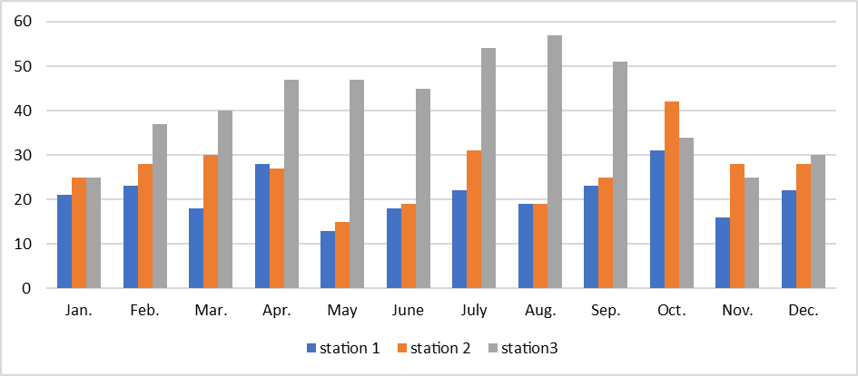

**Discussion or Results and Discussion**

The discussion and results can be combined in one title or be separated, and the journal receives articles or papers in both cases. The discussion should express the importance of the results of the work, not its repetition. Extensive citations should be avoided, and focus should be on comparison with published sources, pointing out aspects of agreement and disagreement, and explaining reasons.

**Conclusions**

The conclusion should be included before the list of the reference of the limanuscript.

**Acknowledgement**

It is important to thank individuals or institutions that have provided support or assistance in any way during the completion of the study or research.

**References:**

To ensure proper citation, all references to other works should be cited in the text by the name and year as they appear in the text. The references should be listed alphabetically. Journal names should be abbreviated. Examples of correctly formatted references are provided below:

**An article/ paper in journal/ periodical/ serial.**

* **If the reference consists of one author:**

Mhaisen, F.T. (2025). Checklists of fish species infected with species of the genus *Clinostomum* Leidy, 1856 (Class Trematoda), the causative agents of the yellow grub disease, in Iraq. Iraqi J. Aquacult., 22(1): 1-16.

*If the DOI is not available, you may include a link to the paper instead.

* **If the reference consists of two authors:**

Uçkun, A.A. and Gökçe, D. (2015). Assessing age, growth, and reproduction of *Alburnus mossulensis* and *Acanthobrama marmid* (Cyprinidae) populations in Karakaya Dam Lake (Turkey). Turk. J. Zool., 39(1): 1-14. [DOI:10.3906/zoo-1211-13](DOI:%2010.3906/zoo-1211-13).

* **If the reference has more than three authors:**

Ali, M.; Diatta, Y.; Alkusairy, H.; Saad, A. and Capapé, C. (2016). First record of Red Sea goatfish *Parupeneus forsskali* (Osteichthyes: Mullidae) from the Syrian Coast (Eastern Mediterranean). J. Ichthyol., 56(4): 616-619. DOI: 10.1134/S0032945216040019.

* **A Book**

Khalifa, K.A. (1986). Fish diseases. Mosul Univ. Press: 266 pp. (In Arabic).

Hassan, H.F. and Hashim, D.S. (2016). Parasites of Mesopotamian fishes. Fatholi Press, Kirkuk: 246 pp. + III. (In Arabic).

* **A Chapter in a Book**

Öktener, A. (2021). The parasites of fishes of the Euphrates and Tigris rivers: Iraq and Turkey. In: Jawad, L.A. (ed.). Tigris and Euphrates rivers: Their environment from headwaters to mouth. Springer, Aquatic Ecology Series, Vol. 11, Chapter 68: 1419-1444.

* **A Paper in the Proceedings of a Conference/ Symposium/ Meeting**

Sorgeloos, P. (2001). Technologies for sustainable aquaculture development, Plenary Lecture II. In: Subasinghe, R.P.; Bueno, P.; M.J. Phillips, M.K.; Hough, C.; McGladdery, S.E. & J.R. Arthur, J.R. (Eds). Aquaculture in the Third Millennium. Technic. Proc. Conf. Aquacult. Third Millennium, Bangkok, Thailand, 20-25 February 2000: 23-28. NACA, Bangkok and FAO, Rome.

Abdul-Ameer, K.N. and Atwan, F.K. (2018). First record of *Tripartiella rhombi* Shtein, 1962(Ciliophora trichodinidae) in Iraq from gills of the common carp *Cyprinus carpio*. Proc. 3rd Agric. Sci. Conf., Coll. Agric., Univ. Kerbala: 5-6 March 2018: 38-42.

* **A Thesis**

Al-Musaedi, A.I.C. (2020). Morphological and molecular study of gastrointestinal helminthes parasites of some fish species in Al-Huwayzah Marsh, Misan/ Iraq. M. Sc. Thesis, Coll. Sci., Univ. Misan: 97 pp.

Al-Saadi, A.A.J.J. (2007). Ecology and taxonomy of parasites of some fishes and biology of *Liza abu* from Al-Husainia Creek in Karbala Province, Iraq. Ph. D. Thesis, Coll. Educ. (Ibn Al-Haitham), Univ. Baghdad: 155 pp. (In Arabic).

* **Internet/ www address:**

Rottmann, R.W.; J. V. Shireman, J.V. and Chapman, F.A. (1991). Hormonal control of reproduction in fish for induced spawning. Southern Regional Aquaculture Center at <http://www.SRAC.Net>.

**IMPORTANT NOTES:**

**1-**The editor has the right to change or alter any paragraph or sentence in the article text if he believes that it is necessary.

**2-** Before submitting the research to the journal, the researcher must check for plagiarism and artificial intelligence, and send the result of the check with the research.

**3-** After completing the second observation, the research will be sent to the scientific reviewers.

**4-** After receiving the response from the reviewers with acceptance and modifications, the files will be sent to the author to make modifications, within a specific time period (two weeks).

**5-** After receiving the modification from the authors, the publication fees in the scientific journal are paid, and the authors receive a document accepting the research before the scientific publication.

**المجلة العراقية للإستزراع المائي المُجَلَّد (00) العدد (0)-2025: 00-00 87 ــــــــــــــــــــــــــــــــــــــــــــــــــــــــــــــــــــــــــــــــــــــــــــــــــــــــــــــــــــــــــــــــــــــــــــــــــــــــــــــــــــــــــــــــــــــــــــــــــــــــــــــــــــــــــــــــــــــــــــ**

**العنوان: يجب أن يكون مختصراً ومحدداً ومرتبطاً بالموضوع**

**(****Times New Roman - 14 font- Bold)**

**الاسم الكامل للمؤلف أو المؤلفين المشاركين/ وفقًا لما يلي: الاسم الأول الكامل واسم الأب ثم اللقب**

مثال: (أحمد كريم سلطان) ثم أدخل معرف ORCID للمؤلفين

**(Times New Roman - 12 font- Bold)**

عناوين المؤلف/المؤلفين حسب: القسم العلمي، الكلية، الجامعة، المدينة، الدولة.

ضع الأرقام (1، 2، 3) بعد أسماء المؤلفين إذا كان المؤلفون ينتمون إلى جهات مختلفة

1 الانتساب الأول

2 الانتساب الثاني. إلخ ...

(Times New Roman - 11 font)

*Corresponding Author E-mail: [mhaisenft@yahoo.co.uk](mailto:mhaisenft@yahoo.co.uk)

(Times New Roman - 11 font)

**ــــــــــــــــــــــــــــــــــــــــــــــــــــــــــــــــــــــــــــــــــــــــــــــــــــــــــــــــــــــــــــــــــــــــــــــــــــــــــــــــــــــــــــــــــــــــــــــــــــــــــــــــــــــــــــــــــــــــــــ**

|  |
| --- |
| تاريخ الإستلام: 00/00/2025 تاريخ القبول: 00/00/2025 تاريخ النشر: 00/00/2025 |
| المستخلص |
| **مطلوب ملخص موجز وواقعي. يجب ان يذكر الملخص بإيجاز الغرض من البحث والنتائج الرئيسية والإستنتاجات الرئيسية. غالباً ما يتم تقديم الملخص بشكل منفصل عن البحث أو المقالة، لذلك يجب أن يكون شاملاً بكل مضامين البحث. لهذا السبب، يجب تجنب ذكر المصادر. ايضاً، يجب تجنب الإختصارات غير القياسية أو غير الشائعة. يجب ألا يزيد المستخلص عن 250 كلمة.**  الكلمات المفتاحية: **عددها 3-5 ومعبرة عن المحتوى.**  (Times New Roman - 11 font) |

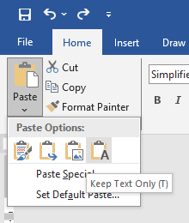

All you have to do is copy the files and then paste them using the option shown in the image on the right (Keep Text Only (T)), into this magazine publication copy, and all the files will be arranged in the same magazine format.